CP5047 - ICT Project 2

*Cycle Report*

# Maggie Maylin

# Hypnotherapy & Clinical Website

# Team 07:

# Srinath Mupparsi Ravindernath

# Keshav Ishwar

# Karthik Nekkarganti

# Executive Summary

# Project Description

The project is about developing a website for hypnotherapy clinic. Maggie Maylin clinical hypnotherapy & counselling, is a self-owned business. The primary goal of this business is to offer hypnotherapy counselling sessions for people. Hypnotherapy can be effective in managing areas to do with anxiety, stress, depression, trauma, smoking, weight loss, alcohol, performance, pain, gambling. The best way to ensure these habits, responses and forms of self-medication are dealt with effectively is to manage the drivers behind them. Hypnotherapy is about life change.

# Team Members work Allocation

|  |  |
| --- | --- |
| Karthik Nekkarganti |  |
| Srinath Mupparsi |  |
| Keshav Ishwar |  |

# Beta Release

The changes suggested by the client after alpha release had been taken into consideration and prioritized it accordingly.

**Start Date: 9th July 2018**

**End Date:**

|  |  |  |  |  |  |  |
| --- | --- | --- | --- | --- | --- | --- |
| Beta  Release | Id | User Story | Description | Priority | Days | Status |
| 1. | Home Page |  |  |  |  |
| 2 |  |  |  |  |  |
| 3 | Contact Info Display | As a Client, I need my contact info needs to be displayed bigger. |  |  |  |
| 4 | Affiliation section | As a Client, I need my affiliations to be displayed smaller on the homepage |  |  |  |
| 5 | Admin Dashboard |  |  |  |  |
| 6 |  |  |  |  |  |
| 7 |  |  |  |  |  |
| 8 |  |  |  |  |  |

# User Stories

1. Home Page: -

* Displaying the Client’s clinic’s full name.
* Email address and phone number should be clearly displayed on top right-hand corner of the menu.
* Menu Should be beneath the main heading

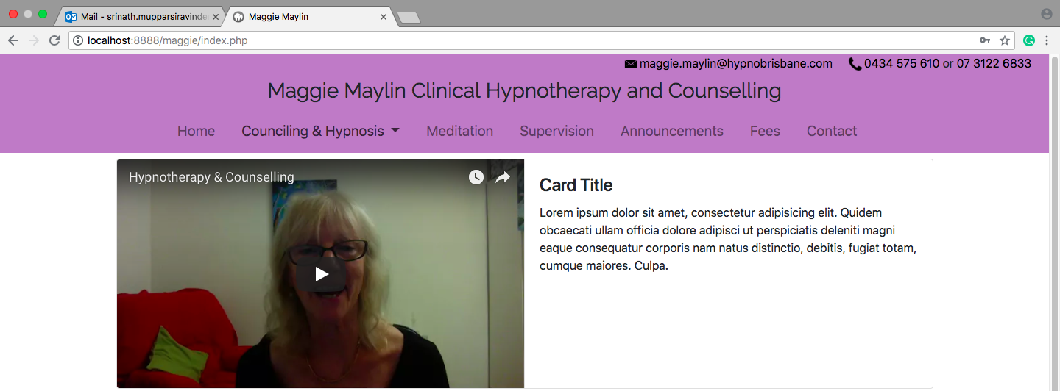

Figure 1: Home Page Menu Section

1. Affiliation section: -
   * Displaying affiliations with no text.

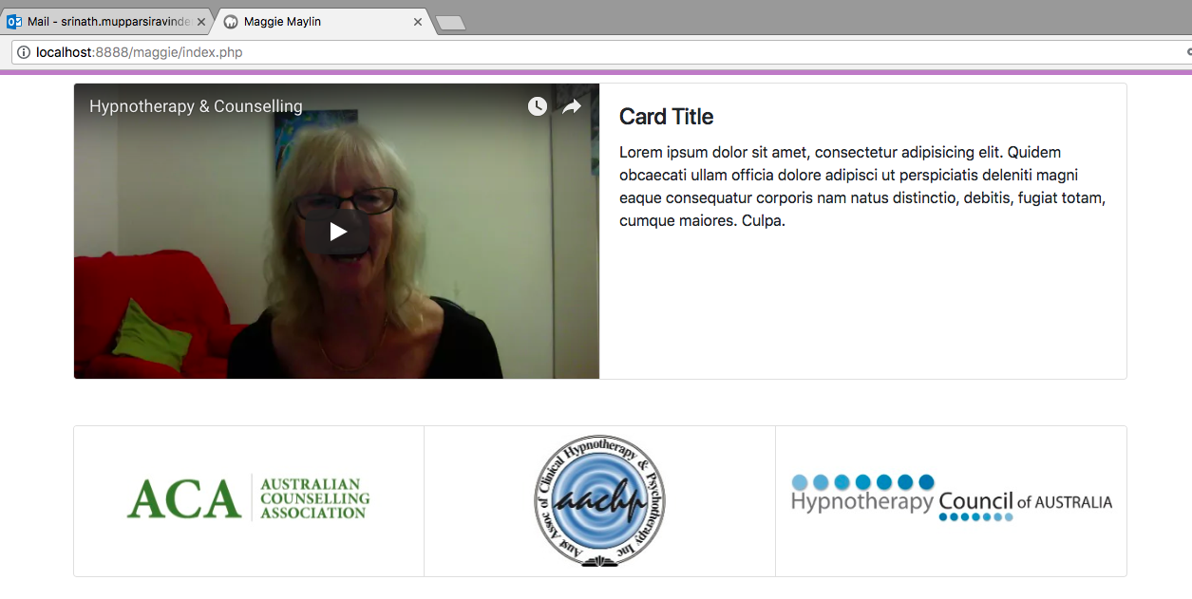

Figure 2: Affiliations Section